Packet Tracer - Investigating Directly Connected Routes

1. Topology

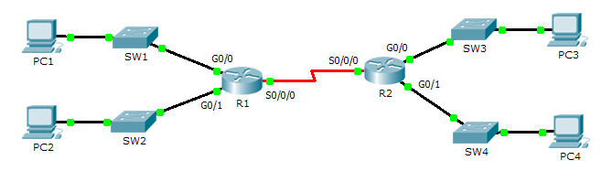

1. Objectives

Part 1: Investigate IPv4 Directly Connected Routes

Part 2: Investigate IPv6 Directly Connected Routes

1. Background

The network in the activity is already configured. You will log in to the routers and use **show** commands to discover and answer the questions below about the directly connected routes.

**Note**: The user EXEC password is **cisco** and the privileged exec password is **class.**

1. Investigate IPv4 Directly Connected Routes
   1. Use show commands to gather information about the IPv4 directly connected networks.

Enter the following command on **R1**:

R1> **show ip route ?**

* + 1. What option would be most beneficial in determining the networks assigned to the interfaces of the router? **Connected**
    2. Which networks are directly connected on **R1**? Hint: Use the option determined above.

**C 172.31.20.0/23 is directly connected, GigabitEthernet0/0**

**C 172.31.22.0/23 is directly connected, GigabitEthernet0/1**

**C 209.165.200.224/30 is directly connected, Serial0/0/0**

* + 1. Which IP addresses are assigned to the LAN interfaces on **R1**?

**R1#show ip interface brief**

**Interface IP-Address OK? Method Status Protocol**

**GigabitEthernet0/0 172.31.21.254 Yes manual up up**

**GigabitEthernet0/1 172.31.23.254 Yes manual up up**

* + 1. Which networks are directly connected on **R2**?

**C 172.31.24.0/24 is directly connected, GigabitEthernet0/0**

**C 172.31.25.0/24 is directly connected, GigabitEthernet0/1**

**C 209.165.200.224/30 is directly connected, Serial0/0/0**

* + 1. Which IP addresses are assigned to the LAN interfaces on **R2**?

**R1#show ip interface brief**

**Interface IP-Address OK? Method Status Protocol**

**GigabitEthernet0/0 172.31.24.254 Yes manual up up**

**GigabitEthernet0/1 172.31.25.254 Yes manual up up**

* 1. Verify PC addressing and test connectivity.
     1. Open a command prompt on **PC1**. Issue the command to display the IP settings. Based on the output, would you expect **PC1** to be able to communicate with all interfaces on the router? Provide a short answer describing your expectations.

**PC memiliki alamat gateway yang benar dan router mencantumkan semua jaringan yang terhubung dalam tabel routing**

* + 1. Open a command prompt on **PC2**. Issue the command to display the IP settings. Based on the output, would you expect **PC2** to be able to communicate with **PC1**? Verify your expectations.

**Ping is successful**

* + 1. Determine the IP addresses of **PC3** and **PC4**. Record the results and determine if **PC3** and **PC4** are able to communicate

**PC3 – IP address 172.31.24.10, PC4 – IP address 172.31.25.10**.

* + 1. Test connectivity from **PC1** to **PC3**. Was the test successful? **Yes**
    2. **Bonus**: Looking at the outputs of the routing tables on **R1** and **R2**, what might indicate a reason for the success or failure of communication between **PC1** and **PC3**? **The default static route 0.0.0.0/0**

1. Investigate IPv6 Directly Connected Routes
   1. Use show commands to gather information about the IPv6 directly connected networks.
      1. Which IPv6 networks are available on **R1**?

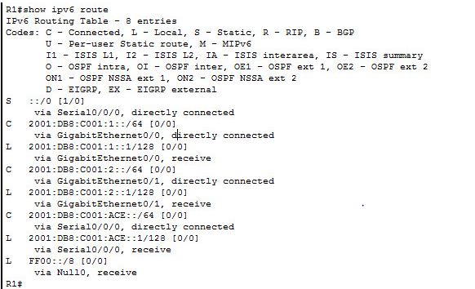

* + 1. Which IPv6 unicast addresses are assigned to the LAN interfaces on **R1**?

**L 2001:DB8:C001:1::1/128[0/0]**

**via::,GigabitEthernet0/0**

**L 2001:DB8:C001:2::1/128[0/0]**

**via::, GigabitEthernet0/1**

* + 1. Which IPv6 networks are available on R2?

**C 2001:DB8:C001:3::/64 [0/0]**

**via ::, GigabitEthernet0/0**

**L 2001:DB8:C001:3::1/128 [0/0]**

**via ::, GigabitEthernet0/0**

**C 2001:DB8:C001:4::/64 [0/0]**

**via ::, GigabitEthernet0/1**

**L 2001:DB8:C001:4::1/128 [0/0]**

**via ::, GigabitEthernet0/1**

**C 2001:DB8:C001:ACE::/64 [0/0]**

**via ::, Serial0/0/0**

**L 2001:DB8:C001:ACE::2/128 [0/0]**

**via ::, Serial0/0/0**

* + 1. Which IPv6 addresses are assigned to the LAN interfaces on **R2**?

**L 2001:DB8:C001:3::1/128 [0/0]**

**via ::, GigabitEthernet0/0**

**L 2001:DB8:C001:4::1/128 [0/0]**

**via ::, GigabitEthernet0/1**

* 1. Verify PC settings and connectivity.
     1. Open a command prompt on **PC1**. Issue the command to display the IPv6 settings. Based on the output, would you expect **PC1** to be able to communicate with all interfaces on the router? Provide a short answer describing your expectations

**PC memiliki alamat gateway yang benar menggunakan tautan alamat lokal pada router dan router mencantumkan semua jaringan yang terhubung dalam tabel routing.**

* + 1. Open a command prompt on **PC2**. Issue the command to display the IPv6 settings. Based on the output, would you expect **PC2** to be able to communicate with **PC1**? Verify your expectations.

**Ping is successful**

* + 1. Determine the IPv6 addresses of **PC3** and **PC4**. Record the results and determine if **PC3** and **PC4** are able to communicate.

**PC3 – IP address 2001 :DB8:C001:3::10/64, PC4 – IP address 2001:DB8:C001:4::10/64**

* + 1. Test connectivity from **PC1** to **PC3**. Was the test successful? **Yes**
    2. **Bonus**: What might indicate a reason for the success or failure of communication between **PC1** and **PC3** after looking at the outputs of the IPv6 routing tables on **R1** and **R2**?

**The default IPv6 Static Route**

**S::/0[1/0]**

**via ::, Serial0/0/0**

1. Suggested Scoring Rubric

|  |  |  |  |
| --- | --- | --- | --- |
| Activity Section | Question Location | Possible Points | Earned Points |
| Part 1: Investigate IPv4 Directly Connected Routes | Step 1 | 25 |  |
| Step 2 | 25 |  |
| Part 2: Investigate IPv6 Directly Connected Routes | Step 1 | 25 |  |
| Step 2 | 25 |  |
| **Total Score** | | **100** |  |